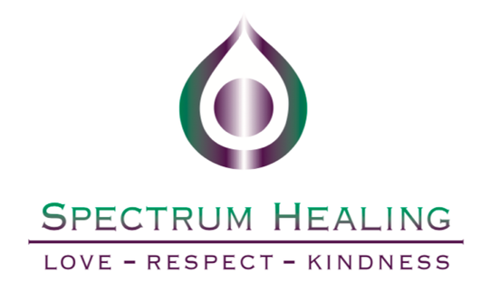

**Wed.27th May. depart AUS and board your flight toEgypt.**

**Note( international flights & Visa Plus Travel insurance arranged by you)**

**Note: ( Please advise your Arrival timing for you Pick up & arrival transfer)**

**Thursday :28th** **May. Day1. Arrival to Cairo Airport, Egypt**

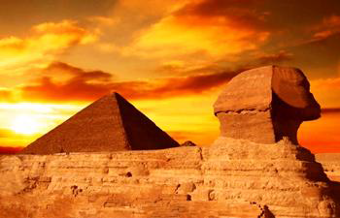

You will be met and assisted at Cairo International Airport and get transferred to your hotel. On the way to your hotel Meet up with your Egyptologist / Tour Manager and spent some time reviewing & enjoying an introductory talk for Egypt plus highlighting the tour itinerary & logistics’ . Enjoy the rest of the day at your leisure.

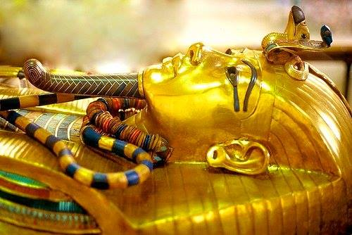

**Inclusions: Meet & assistance at airport, Airport Transfers**

**Meals: N/A**

**Exclusions: Egyptian Visa & International Air-Ticket.**

**Hotel: Mena House Marriott**

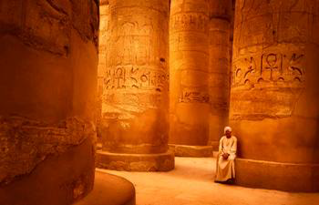

**Friday. 29th May. Day 02: Free day intro session with Donna**

Today we will enjoy an intro session with Donna and group members, great chance to set your spiritual path and to get ready for the coming few days . This afternoon we will depart the hotel to enjoy sound and light show at Giza Pyramids and later we will enjoy our special dinner outside hotel.

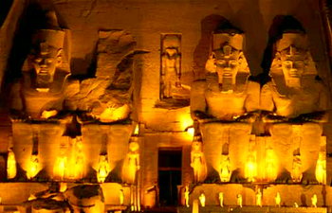

**Meals: Breakfast & Dinner outside**

**Inclusion: sound & light Show**

**Inclusion: Intro session**

**Sat 30th .may Day 3 Cairo ( Giza Pyramids & Museum )**

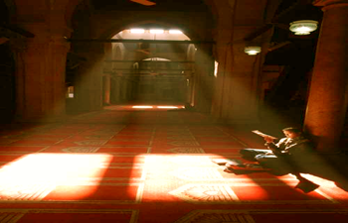

Early morning, enjoy a private entry (before common tourists enter the area) to the Giza Pyramids, her we will connect with the energies of the Great Pyramid you will feel a sense of a doorway between dimensions opening. Here we will crawl through ancient passages into the deepest corners of our souls. The Great Pyramid is also a representation of the human skull, and therefore the King's Chamber is representing the core centre of the Earth, and therefore representing the core centre of the human brain! So Chamber of the Great Pyramids is the Crown Chakra. The Ancient Egyptians believed that it was here that they taught the mystery of the immortality of the soul. It is evident that the knowledge possessed during the times the Pyramids are said to have been built included a complete grasp of astronomy, solar systems, planetary bodies, distances, the procession of the equinoxes and the fixed star groupings, sacred geometry, advanced mathematics, physics, geography. Later on we will move to the Sphinx "the soul star" pathway to accessing ancient knowledge through meditation and divination. Later on we will stop by essential oil palace to learn and try plus to shop the 07 sacred oils. After lunch we will The Egyptian Museum and King Tut collections’ with its golden mask and coffins. Your guide will take you on an exploration of these fascinating ancient monuments. Before departing the Museum you will have time to explore some of the displayed artifacts and the royal mummy gallery (***Extra Coast)***.

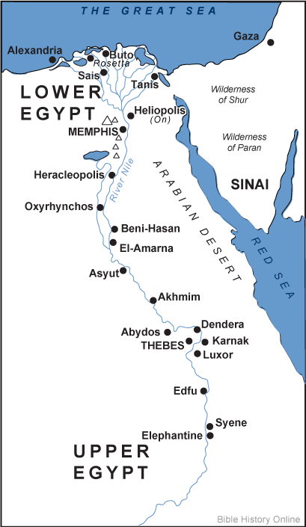

Tonight we will dine Seafood meal .

**Inclusions: Private tour Giza Pyramids & Egyptian Museum**

**Meals: Breakfast & early sea food Dinner outside hotel**

**special feature: Private entry to Giza Pyramids**

**Shopping: Essential Oils**

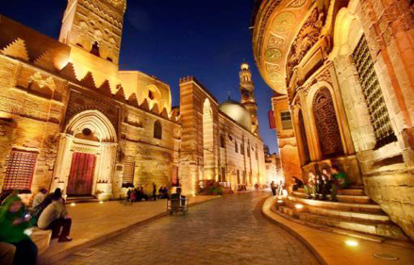

**Extra: Mummy Room at Museum ( 15 USD Per Person )**

**Sun.31st May. Day 04: Cai/LXR ( Karnack & Luxor temples )**

Early morning (**Breakfast Box**) we will drive to Cairo International airport (Domestic Hall) to board your domestic flight to Luxor. **( MS. …. at …… - ……….)** upon arrival Meet & assist in Luxor Airport. Luxor (the fortification) with its vast array of ancient temples and monuments, Luxor is often called the world’s greatest open-air museum. Discover the sights of the East bank of the Nile today. upon arrival we will wander among the massive 134 pillars of the Temple of Karnak; this is the Solar Plexus chakra. "The tradition of the ancient world is called The Masters of the Net, an illustration from the temple walls at Karnak, showing Thoth, the Ibis headed God, who stands behind the Egyptian high culture, stretching a cord, to give the extent of spirit moving in to physical space. While the Masters of the Net was one expression of the type of initiation that took place in great spiritual systems, to teach initiates how spiritual forces can be brought in to manifestation in the physical world, this net that is being described is the same thing that we find in modern physics as The Net of Space Time ." The temple of Karnak describes the process of the creation of the manifest universe, the descent of spirit into matter using the Golden Blueprint of Creation. The essence of Karnak temple comes most alive in a small sanctuary dedicated to Sekhmet the lioness goddess of healing and war. We will walk through the seven doors into Sekhmet's temple and experience the magnificent energies of healing and activation that she offers. We next visit Luxor temple which is also associated with the Third chakra. The Temple of Luxor describes the structure of the human body, incorporating its energy centers, the Chakras . By midday we will check in at our hotel rest of the afternoon free at your leisure so you might like to join one of our Optional extra excursions of Luxor City. a Calash Ride (horse drawn carriage) for 90 Minutes around Luxor’s rural & local markets. Real experience for photographing People & see real culture.

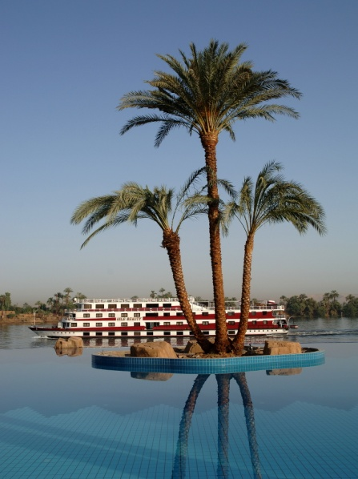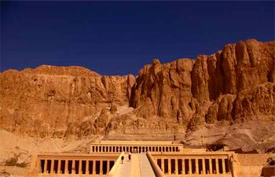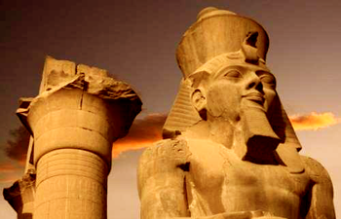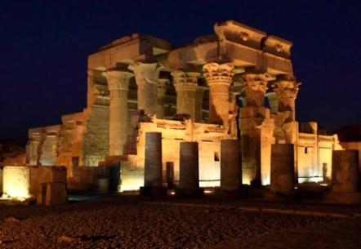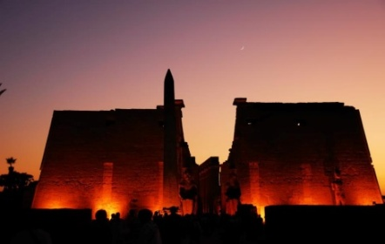

**Inclusion: Domestic Flight ( Cairo / Luxor) economy Class**

**Inclusion: Karnak & Luxor Temples**

**Meals: Breakfast, & Dinner**

**Extra: Horse & Carriage ( 20 USD Per Person )**

**Hotel: Sonesta St. George or Luxor Nile Hilton**

**Mon. 1st Jun.. Day 05: Dandara temple**

This Morning after breakfast we will drive north the Nile to Explore The most beautiful temple on the Nile and its sanctuary at Dendarah, dedicated to Hathor, the goddess of love. Naturally, this center corresponds to the heart chakra **.** lunchtime we will board our Nile Cruise , rest of the afternoon free at leisure and enjoy Donna healing session onboard

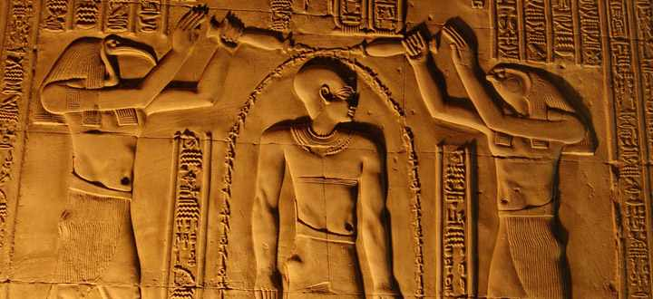

Today we will have a chance for exploring the world of Precious stones Lapis & Turquoise and hundreds of other type with the famous Egyptian Gold cartouches to make your name in Hieroglyphic and silver items by visiting the famous jeweler shop in Luxor

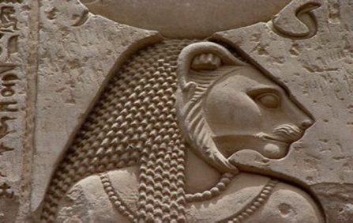

**04 nights await you to relax on a wonderful River Cruise. You will enjoy cruising down the mysterious Nile River; the longest river in the world. This is a great opportunity to kick-back and watch Life on the banks of the Nile going by. Our meals start with lunch, a mixture of delicious local & international dishes served onboard. There are two stops on the way to Aswan; to pass Through the Nile Lock (Esna City).the second for a temple visit Kom-Ombo or Edfu.**

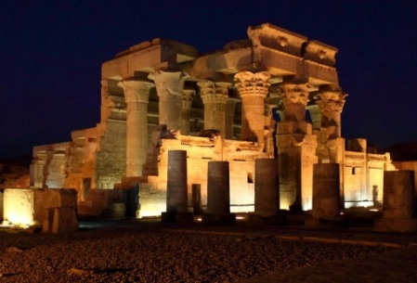

**Inclusion: Dandara Temple**

**Inclusions: Healing session**

**Exclusion: Drinks onboard including water**

**Extra: Sound & Light Show ( 45 – 55 USD )**

**Nile Cruise: Sonesta ( Star or Sun Goddess )**

**Shopping : semi precious stone , Gold & Silver Items**

**Tue. 2nd Jun.. Day 06: Luxor W. Bank ( Kings’ Valley & Hatshipsuit Temple )**

06.00 After breakfast. we cross the Nile to visit the vast burial city called the Necropolis of Thebes, on the West Bank of the Nile. we will stop at the fabled Colossi of Memnon and the Temple of Hatshepsut (the first female rulers and the suggested princes that rescued Moses from the Nile River), her funerary amazing carved out rock temple and its terraces is worth the early morning start enjoy ( Hathor chapel and get connected to the feminine spirit of the temple) . Later we will wander at the Valley of the Kings, step from a sun-drenched landscape into the dark silence of the tombs(3 different tombs).) before departing the West Bank a quick stop at a local stone cutter factory (Alabaster Shop) for watching how the ancient cut and sculpted their monuments and exploring the ancient imitation of antique or replicas with alabaster & basalt plus granite statues . Return back to the boat, a buffet lunch will be served start sailing to Esna. The afternoon can be spent relaxing on the sundeck while watching the varied local life on the river and its banks. Afternoon tea will be served on the sun deck. dock overnight in Edfu.

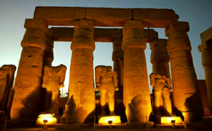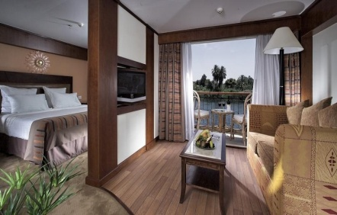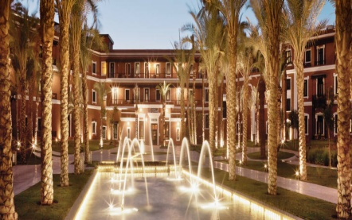

**Inclusions: Luxor West Bank Excursions Meals: Breakfast, Lunch, and Dinner (Drinks Excluded) Shopping: Alabaster & Granite workshop**

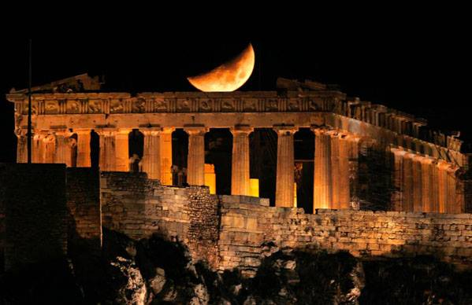

**Extra Optional: Hot Air Balloon ( 150 - 170 USD)**

**Wed. 3rd Jun. Day 07: EDFU / Aswan Overnight**

Breakfast on board. Visit the Temple of Horus in Edfu. Sail to Aswan via Kom Ombo city and temple (at the Navel Chakra. This temple is dedicated to two gods, Sobek and Ra Hr Akhty. Sobek is the crocodile god who represents the Lower Self, and the god Ra Hr Akhty — Horus Who Is In the heaven — represents the Higher Self. This temple holds the Atlantean energy. If you are ready for this experience you will detach from the struggles of own higher and lower self, to let go of fear and negativity as we see the struggle between the higher and lower selves depicted on the temple walls) later we will continue sailing till we approach Edfu (still in the area of the Navel Chakra — we see the struggle of good and bad through the story of Isis, Osirus, Set and Horus. At Edfu temple you will connect with your hidden emotions. We will visit the sanctuary in the rear of the temple - temple of Horus - his energy is still very present). In the evening there will be a Galabeya party, where everyone dresses up in traditional Egyptian costumes for dinner and party games. Late that night the boat will dock in Aswan for a stay of two nights.

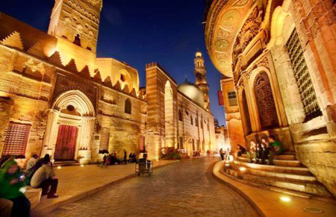

***N.B. Pls Consider Cruise Itinerary may get changed***

**Inclusion: Edfu & Kom Ombo Temples Meals: Breakfast, Lunch, Dinner. (Drinks Excluded)**

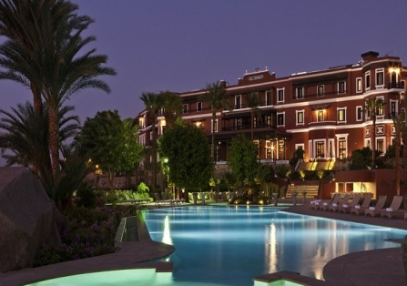

**Thu.4th Jun. Day 08: ASWAN: Philea Temple& High Dam**

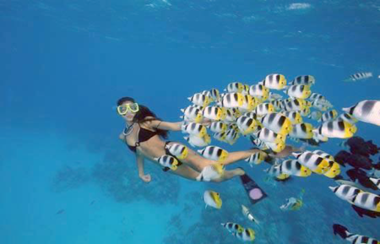

Aswan: Land of Gold. it provides shelter and a resting place for migrating birds from Europe, in their winter season migration journey. Aswan is the house of the Nubians: is the only pure ancient Egyptian race left. Aswan: Land of Gold plus the house of the Nubians: the only pure ancient Egyptian race left. Aswan is considered the Root Chakra. The main god of Aswan is Khnum, the ram-headed god — the god of creation who sits on the potter's wheel and forms and makes individuals out of clay. When visiting Aswan, many people experience what is described as "a new birth." Upon arrival we will Visit the temples of [Philae](https://www.memphistours.com/Egypt/Egypt-Wikis/aswan-attractions/wiki/Philae-Temple) for Goddess Isis and later we will explore the high Dam.. rest of the evening free at your leisure

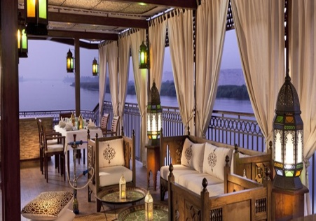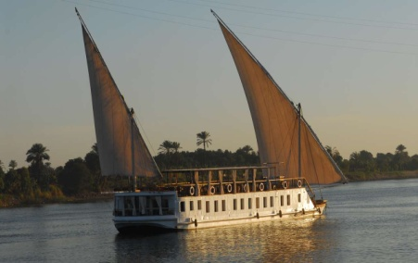

**The rest of the afternoon is free, or you might like to join an optional extra Nubian Village Tour. Cruise the river in a simple motorboat to a lovely Nubian village. There you will enjoy a wonderful time with villagers who will sing and dance for your entertainment. You can watch the Nile scenery, including nesting migrating birds from Europe. This trip includes a camel ride in the heart of the Sahara Desert, before visiting one of the Nubian Houses and meeting the Family.**

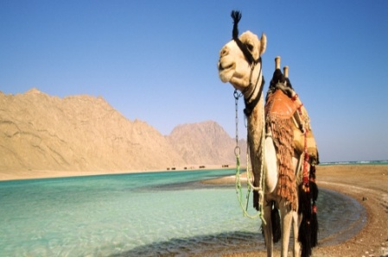

**Inclusion: High Dam & Philae temple tour . Meals: Breakfast, Lunch, Dinner. (Drinks Excluded)**

**Extras: Nubian Village Tour (approx. $ 45 - 55 USD per Person)**

**Shopping: Gold & Silver**

**Fri.5th Jun. Day 09: Aswan/Cairo Flights.**

This Morning we will disembark our boat and we will check fly to Cairo. From Aswan we will board **( Ms. …………….. )** arriving Cairo , upon arrival we will drive outside Cairo & explore Sakkara enhancing our Throat Chakra. it is aligned with God Thoth the enlightened communicator, the holy scribe and wisdom keeper. This intuitive center associated with the gift of teaching, communication, and cultural knowledge. Sakkara opens the portal to communication, growth, expansion and speaking ones higher personal truth, we will later explore Rug school and enjoy light Egyptian Lunch ( Egyptian Falafal & Shawarma Sandwiches ) then we will check in at our Hotel .

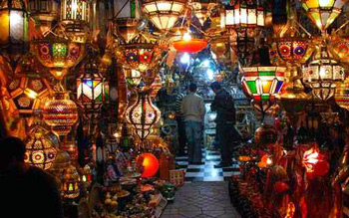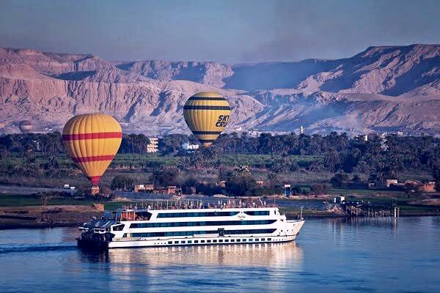

**Inclusions: Sakarra**

**Meals: Breakfast, Sandwiches Lunch & Special Egyptian Dinner outside Hotel**

**Inclusion: Aswan / Cairo Flight.**

**Shopping: Carpet School**

**Sat. 6th Jun. .Day 10: Coptic, Islamic Tour & Healing Session .**

After breakfast at 07.30 , we will depart the hotel to explore Coptic Cairo walking on the ancient holy family footprints, where visiting the famous site that sheltered the holy family in their fleet to Egypt (the Crypt ) Church. Later on we will drive to Islamic Cairo where we will visit the Famous Sultan Hassan Mosque where we will dive into our own personal peace and soul , on our way to the hotel we will stop by papyrus factory to learn how ancient Egyptian used to make their long lasting paper and to shop as well . Back to hotel to Rest and free evening at your leisure.

by 13.00 we will end our spiritual experience with farewell session & later we will have our farewell dinner

**Inclusions: farewell Healing Session**

**Inclusion: Mosque & Coptic Cairo.**

**Shopping: Papyrus Gallery**

**Meals: Breakfast & farewell Dinner at hotel**

**Note: ( Please advise your departure timing for you final transfer )**

**Sun 7th Jun .Day 11: Cairo (Home)**

After Breakfast you will get transferred to Cairo international airport for boarding your international flight back home . (end of our service)

**Meals: Breakfast**

**Exclusion: International flight, Departure Tax.**

**\* Price per Person for ultimate Spiritual Egypt 10 Nights/11 Days**

**Ultimate 05 stars Spiritual Retreat**

**Only for ($ 3595 USD) . In twin Double Room.**

**Single Supplements ($ 1450 USD)**

**Cairo hotel: ( Marriott Mena House or Fairmont Nile City)**

**Nile Cruise: Sonesta Stars or Sun Goddess or Movenpick Royal Lily.**

**Luxor: ( Sonesta St. George hotel or Hilton Plaza Luxor )**

**Tour detailed & Price Inclusions:**

**Cairo:**

1. **05 Nights stay at 5 stars deluxe Hotel on Half board Basis**

**Nile Cruise :**

**04 Nights onboard: ( 5 stars deluxe Cruise on full board**

**accommodation B, L,D**

**Luxor : 01 night at hotel on half board Basis**

1. **Domestic Flights (Cairo / Luxor & Aswan / Cairo ) economy class**
2. **Meals: as mentioned on the itinerary (10 Breakfast, 5 Lunch, 10 Dinner) .**
3. **Arrival & Departure Transfers plus Meet & Assist at Airports, and all excursions with Air-conditioned tourist Bus.**
4. **Entrance Fees to the Above Mentioned sights.**
5. **All excursions as listed on the itinerary.**
6. **Qualified expert English Speaking Guide/Egyptologist / tour manager escorting the tour from day 1 to day 11. ( From Cairo to Aswan )**
7. **Private entry to Giza Pyramids (from 05.00 to 08.00 )AM.**
8. **Taxes & Police permissions**
9. **Sound & Light show at the Pyramids area**
10. **Special visit to Dandara temple.**
11. **Felucca trip on the Nile**
12. **Daily 02 bottles of water.**

**Price Exclusions:**

**Tipping for the whole tour : Please allow $ 150 USD Per Person ) to be collected as a kitty and distributed among Egyptologist , Porters, Drivers, Reps, Waiters, Nile Cruise, etc.**

* **Extra Meals not listed on the itinerary (average lunch coast 10 – 20 USD per person per meal ),**
* **Drinks along the tour including water even on the Cruise .**
* **Personal Items: Laundry, Phone Calls, Internet, Shopping, personal tipping at restaurants, toilets, Temples ... Etc**
* **Extra Excursions or anything not list on the itinerary**
* **International Flights, Egyptian Entry Visa & Departure Tax.**
* **Travel Insurance**

**Note: any sudden increase of fuel or Taxes or entrance fees by the government ( the prices / additions will be added to the tour price without notifications.**

**Links**

**Cairo:**

***Mena House*** : [**https://www.marriott.com/hotels/travel/caimn-marriott-mena-house-cairo/?scid=bb1a189a-fec3-4d19-a255-54ba596febe2**](https://www.marriott.com/hotels/travel/caimn-marriott-mena-house-cairo/?scid=bb1a189a-fec3-4d19-a255-54ba596febe2)

***Or Nile Fairmont:*** [***https://www.fairmont.com/nile-city-cairo/***](https://www.fairmont.com/nile-city-cairo/)

**Nile Cruise:**

**Sonesta Star Goddess:** [**https://www.sonesta.com/africa/nile-cruises/sonesta-star-goddess-nile-cruise-ship**](https://www.sonesta.com/africa/nile-cruises/sonesta-star-goddess-nile-cruise-ship)

|  |  |
| --- | --- |
| **To book your international flight from Sydney to Cairo**  **I recommend this amazing lady who is also a member of the Spectrum Family**  **Hayley Powell** *Travel Guru at* *Perfect Travel Group* | |
|  | w: [perfecttravelgroup.com](https://perfecttravelgroup.com)  p: +61 2 9939 0890  t: 1300 009 283  a: Level 2 17 Carter Rd Brookvale NSW Australia 2100  Why Book With Us? [Traveller Care Guarantee](https://www.perfectwavetravel.com/contact-us/why-book-with-the-perfect-wave)     |  |  |  |  | | --- | --- | --- | --- | |  |  |  |  | |